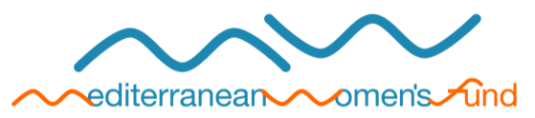

Thank you for your interest in the Mediterranean Women’s Fund.
To enquire about the possibility of funding from us please complete this form and return it via mail to request@medwomensfund.org

Date:

Information about your organisation
1. Name of the organisation
2. Date of creation
3. Registered address
4. Email, telephone, fax, website
5. Goals and main areas of work
6. Name, age and gender of leaders (three at least)
7. Name and title of contact person(s)
8. Names of two women’s organizations with which you have worked
9. Describe some achievements of your organization (if this project is your first, please tell us)
10. How did you hear about the Mediterranean Women's Fund?

Your grant enquiry
You are requesting funding for
- Operating costs? Explain
- A specific project? If so, please specify:
  - Project title
  - What activities do you plan to carry out with funding from the Mediterranean Women’s Fund? (Describe in 3 lines)
  - What impact do you seek to achieve through the proposed activities?

Brief budget information (in euro)
Total budget of the organization
Previous year
Current year
Projected next year
Total budget of the project
Total amount requested from the Mediterranean Women’s Fund (up to 5000 €)

Please note that the completed form should not be longer than 2 pages.
The completed form will be submitted to an initial selection process and you will receive an answer within 6 weeks.
If there is an interest in your project, you will be invited to present a more detailed proposal.

